International Department  Students Welcome Centre –Language Tandems  hu.berlin/welcomecentre-students | 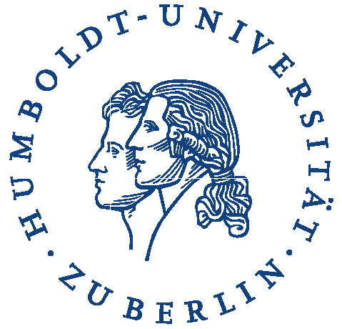

Registration Form for Language Tandems
- Please fill it in and send it to sprachtandems@hu-berlin.de -

Date:
Looking for (desired language):

Offering (native language):

Name Surname male female divers

E-mail address:

Age / Semester: /

Field of study at the university:

Interests:

For international students:

Home country: Duration of stay in Berlin:

Language tandems settings and preferences:

What would you like to learn? (Please tick the boxes below)

Grammar and exercises / Correction of written works / Conversational skills /
Reading and discussion of articles, books, (etc.) Cultural activities: cinema, theatre, exhibitions, concerts (etc.)

What can you offer to your tandem partner? (Please tick the boxes below)

Grammar and exercises / Correction of written works / Conversational skills /
Reading and discussion of articles, books, (etc.) Cultural activities: cinema, theatre, exhibitions, concerts (etc.)

How much time would you like to dedicate to your tandem
partnership (per week/per month) /

My tandem partner should be female / male / divers . It does not matter .

--------
Please let us know if your tandem partnership was successful.
We are thankful for any suggestions for improvement.

